Pulsatilla halleri
‘Budapest’ seedling

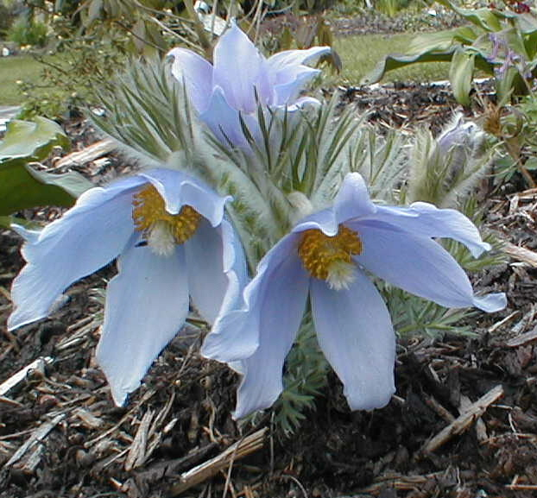

Pulsatilla halleri ‘Budapest’ is one of the most admired and sought after member of the genus Pulsatilla. The true form of this plant is now very rare in cultivation. There are numerous Budapest seedlings in cultivation and while they are quite delightful, they rarely have that magic ice-blue colour of the parent. In 1920, Mrs Dorothy Garton saw some pulsatilla flowers for sale in Budapest and subsequently discovered they had come from Suab Hegy, a mountain west of the city. Later, she was able to collect seed and introduce it to her garden.
The plant in our garden is a seedling, raised from seed received from Harold McBride. The seed was sown in February using a mix of equal parts of JN1; Sharp Grit & Peat. By June the seed had germinated. When the seedlings had formed their first true leaves and were large enough to handle we transplanted them on using the same mix. We kept them growing in the alpine house for the next three years. We then decided to put it out into the garden. To our joy it had 5 flowers last year and this year 15 flowers so our P. Budapest seedling seems to be happy out in the garden.

NB Many thanks to Harold McBride for information on
Mrs Dorothy Garton.

